**Academic Year 2022 - 2025**

**“At BIS, our learners are taught how: to communicate responsibility, build a secure and positive digital footprint and know how to get support when online.”**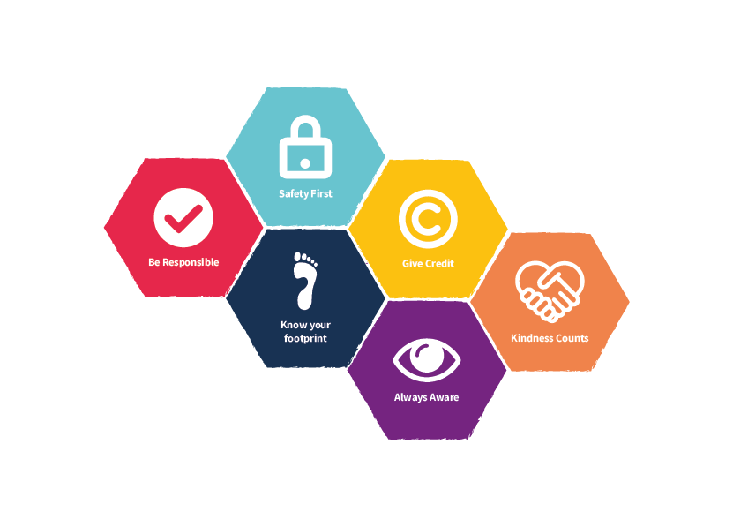

**Sources:**

Common Sense Media Framework [1]

PSHE Association

UK National Curriculum 2018

UK Council for Safer Internet 2020 [2]

**Key**

|  | **EYFS** |
| --- | --- |
|  | **Key Stage 1** |
|  | **Key Stage 2** |

| **ICT** | **Term 1**  **1st Half** | **Term 1**  **2nd Half** | **Term 2**  **1st Half** | **Term 2**  **2nd Half** | **Term 3**  **1st Half** | **Term 3**  **2nd Half** |
| --- | --- | --- | --- | --- | --- | --- |
| **EYFS** | **Kapow PSHE Program and Partnership for children scheme of work** | | | | | |
| **Year 1** | **Media Balance**  [Importance of media balance](https://www.commonsense.org/education/uk/digital-citizenship/lesson/media-balance-is-important)  How do we find a happy balance between our online and offline activities?  Resources: [Digital Citizenship Stories](https://drive.google.com/drive/folders/1Q0uGlYG6DDbYO3tRgAxES8V9DK2aj5ic?usp=sharing) | | **Privacy and security**  [Safety In my online neighbourhood](https://www.commonsense.org/education/uk/digital-citizenship/lesson/safety-in-my-online-neighbourhood)  How do you go places safely online? | | **Media Well-being**  [Pause for people](https://www.commonsense.org/education/uk/digital-citizenship/lesson/pause-for-people)  How do you say goodbye to technology when you don't want to? | |
| **Year 2** | **Online relationships**  [Pause and think online](https://www.commonsense.org/education/uk/digital-citizenship/lesson/pause-think-online)  How can we be safe, responsible and respectful online?  Resources: [Digital Citizenship Stories](https://drive.google.com/drive/folders/1Q0uGlYG6DDbYO3tRgAxES8V9DK2aj5ic?usp=sharing) | | **Media Balance**  [How Technology Makes You Feel](https://www.commonsense.org/education/uk/digital-citizenship/lesson/how-technology-makes-you-feel)  Why is it important to listen to your feelings when using technology? | | **Privacy and security**  [Internet Traffic Light](https://www.commonsense.org/education/uk/digital-citizenship/lesson/internet-traffic-light)  How do you stay safe when visiting a website or app? | |
| **Year 3** | **Media Balance**  [We, the Digital Citizens](https://www.commonsense.org/education/uk/digital-citizenship/lesson/we-the-digital-citizens)  How can we be good digital citizens?  [Device-Free Moments](https://www.commonsense.org/education/uk/digital-citizenship/lesson/device-free-moments)  Why is it important that we have device-free moments in our lives?  Resources: [Digital Citizenship Stories](https://drive.google.com/drive/folders/1Q0uGlYG6DDbYO3tRgAxES8V9DK2aj5ic?usp=sharing) | | **Privacy and Security**  [That's Private!](https://www.commonsense.org/education/uk/digital-citizenship/lesson/thats-private)  What kinds of information should I keep to myself when I use the internet?  **Digital Footprint & Identity**  [Digital Trails](https://www.commonsense.org/education/uk/digital-citizenship/lesson/digital-trails)  What information is OK to have in your digital footprint? | | **Relationships & Communication**  [Who Is in Your Online Community?](https://www.commonsense.org/education/uk/digital-citizenship/lesson/who-is-in-your-online-community)  How are we all part of an online community?  **Cyberbullying**  [Putting a STOP to Online Meanness](https://www.commonsense.org/education/uk/digital-citizenship/lesson/putting-a-stop-to-online-meanness)  What should you do if someone is mean to you online? | |
| **Year 4** | **Media balance & well-being**  [Your Rings of Responsibility](https://www.commonsense.org/education/uk/digital-citizenship/lesson/your-rings-of-responsibility)  How do digital citizens take responsibility for themselves, their communities and their world?  **Privacy & security**  [Password Power-Up](https://www.commonsense.org/education/uk/digital-citizenship/lesson/password-power-up)  How can a strong password help protect your privacy?  Resources: [Digital Citizenship Stories](https://drive.google.com/drive/folders/1Q0uGlYG6DDbYO3tRgAxES8V9DK2aj5ic?usp=sharing) | | **Relationships & communication**  [Our Digital Citizenship Pledge](https://www.commonsense.org/education/uk/digital-citizenship/lesson/our-digital-citizenship-pledge)  What makes a strong online community?  **Cyberbullying**  [The Power of Words](https://www.commonsense.org/education/uk/digital-citizenship/lesson/the-power-of-words)  What should you do when someone uses mean or hurtful language on the internet? | | **Digital footprint & identity**  [This Is Me](https://www.commonsense.org/education/uk/digital-citizenship/lesson/this-is-me)  How does what I post online affect my identity?  **News & media literacy**  [Is Seeing Believing?](https://www.commonsense.org/education/uk/digital-citizenship/lesson/is-seeing-believing)  Why do people alter digital photos and videos? | |
| **Year 5** | **Media balance & well-being**  [My Media Choices](https://www.commonsense.org/education/uk/digital-citizenship/lesson/my-media-choices)  What makes a healthy media choice?  **Privacy & security**  [Private and Personal Information](https://www.commonsense.org/education/uk/digital-citizenship/lesson/private-and-personal-information)  What information about you is OK to share online? | | **Relationships & communication**  [Keeping Games Fun and Friendly](https://www.commonsense.org/education/uk/digital-citizenship/lesson/keeping-games-fun-and-friendly)  How can I help myself and others be positive and have fun while playing online games?  **Cyberbullying**  [Be a Super Digital Citizen](https://www.commonsense.org/education/uk/digital-citizenship/lesson/be-a-super-digital-citizen)  How can we be upstanders when we see cyberbullying? | | **Digital footprint & identity**  [Our Online Tracks](https://www.commonsense.org/education/uk/digital-citizenship/lesson/our-online-tracks)  How does our online activity affect the digital footprints of ourselves and others?  **News & media literacy**  [A Creator's Rights and Responsibilities](https://www.commonsense.org/education/uk/digital-citizenship/lesson/a-creators-rights-and-responsibilities)  What rights and responsibilities do you have as a creator? | |
| **Year 6** | **Media balance & well-being**  [Finding My Media Balance](https://www.commonsense.org/education/uk/digital-citizenship/lesson/finding-my-media-balance)  What does media balance mean for me?  **Privacy & security**  [You Won't Believe This!](https://www.commonsense.org/education/uk/digital-citizenship/lesson/you-wont-believe-this)  What is clickbait and how can you avoid it? | | **Relationships & communication**  [Digital Friendships](https://www.commonsense.org/education/uk/digital-citizenship/lesson/digital-friendships)  How do you keep online friendships safe?  **Cyberbullying**  [Is It Cyberbullying?](https://www.commonsense.org/education/uk/digital-citizenship/lesson/is-it-cyberbullying)  What is cyberbullying and what can you do to stop it? | | **Digital footprint & identity**  [Beyond Gender Stereotypes](https://www.commonsense.org/education/uk/digital-citizenship/lesson/beyond-gender-stereotypes)  How do gender stereotypes shape our experiences online?  **News & media literacy**  [Reading News Online](https://www.commonsense.org/education/uk/digital-citizenship/lesson/reading-news-online)  What are the important parts of an online news article? | |

1. <https://www.commonsense.org/education/uk/digital-citizenship>
2. <https://assets.publishing.service.gov.uk/government/uploads/system/uploads/attachment_data/file/896323/UKCIS_Education_for_a_Connected_World_.pdf>